Problem 4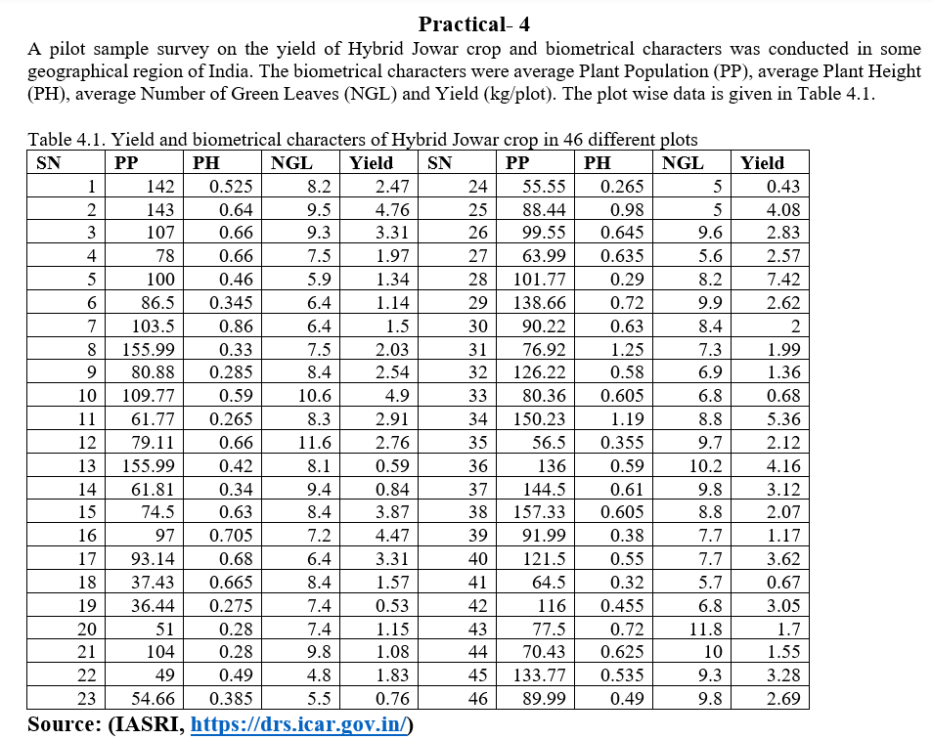
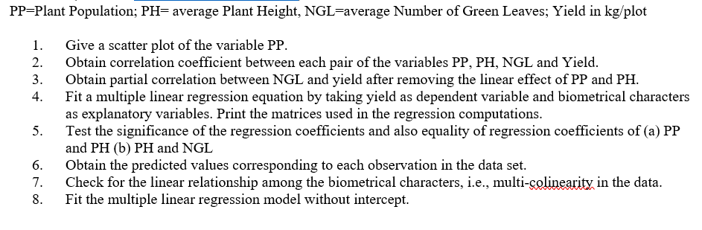
- "Graphs" > "Scatter/Dot" > "Simple Scatter." > "PP" as the x-axis variable > ok
- "Analyze" > "Correlate" > "Bivariate." > Select "PP," "PH," "NGL," and "Yield" as variables. > "OK"
- Analyze > Correlate > Partial > Yield and NGL to the Variable List > PP and PH to the Controlling List.

- Analyze > Regression > Linear > Choose "Yield" as the dependent variable and "PP," "PH," and "NGL" as independent variables. > Click "Statistics" and select "Coefficients", “collinearity diagnostics” and "Model fit."> Statistics > linear regression > Click "OK" to run the regression.
- Analyze > Regression > Linear > Put “Yield” as dependent variable and the rest as covariates > Go to “Save” and then select Unstandardized predicted values and residuals.
- Analyze > Regression > Linear > Put “Yield” as dependent variable and the rest as covariates > From “Options”, uncheck “Include constant in equation”.

Problem 5
Problem:
The data on 98 students is given in the followign table:

Table 5.1. Blood group, Height and Weight of 98 students selected for a study
Gender | Blood group | Weight | Height | Gender | Blood group | Weight | Height
FEMALE | B | 52 | 162 | FEMALE | O | 63 | 165
FEMALE | B | 65 | 174 | FEMALE | O | 59 | 165
Male | O | 89 | 170 | FEMALE | A | 75 | 163
FEMALE | A | 66 | 178 | FEMALE | A | 63 | 158
FEMALE | A | 62 | 160 | Male | B | 80 | 183
FEMALE | O | 62 | 165 | FEMALE | O | 55 | 152.5
FEMALE | A | 62 | 165 | FEMALE | B | 68 | 160

- Construct clustered bar diagram for the variable gender type with clusters as blood group by showing frequency as labels in the bars. Export the bar diagram.
- Draw a gender wise and blood group wise histogram for the variable Height.
- Construct boxplot for height and weight with respect to the gender type. Determine outliers ifany.
- Draw a Pi chart for the blood group with showing the data labels as % values.
- Draw a scatterplot between height and weight. Further, edit the graph, and print the selected parts of the output.

- Graphs>Legacy Dialogs> Bar> Clustered> Summaries for group>Define>N of cases>Category axis: Gender> Define Clusters by: Blood Group.
- Graphs>LegacyDialogs>Histogram>Variable:Heights>Columns:Gender>Rows:BloodGroup
- Graphs>Legacy Dialogs>Boxplots>Summary of separate variables>Boxes Represent:Weight,Height.

- Graphs>Legacy Dialogs>Pie> Summaries for group>Define>% of cases> Define Slices by:Blood_Group
- Graphs>Legacy Dialogs> Scatter Plot>Summaries for group>X axis: Height, Y axis: Weight

Problem 6
Table 1.1 observations of the cow milk weight having different diet of fodder
Fodder Type | cow milk weight | Fodder Type | cow milk weight
1 | 6.08 | 2 | 6.96
1 | 6.70 | 2 | 7.71
1 | 6.50 | 2 | 7.52
1 | 6.86 | 2 | 7.15
1 | 6.17 | 2 | 7.33

- Test whether the mean of the cow milk weight (kg) is 7.0 or not.
- Test whether the Fodder Type A and Fodder Type B are equally effective or are significantly different.
- Test whether Fodder Type B is better alternative in comparison to Fodder Type A.

- Analyse > Compare Means > One-Sample T Test. > cow milk weight as the Test Variable > Test Value as 7.0 > Ok.
- Analyse > Compare Means > Independent Samples T Test.> cow milk weight as the Test Variable(s) > Fodder Type as theGrouping Variable > Define the groups (1 for Fodder Type A and 2 for Fodder Type B) > ok.

Problem 7 A two-way ANOVA
The data on plasma calcium concentrations (in mg/100 ml) of birds of both male and female, half of the birds of each sex being treated with a hormone and half not treated with the hormone were recorded (Table 7.1).
Test the following
H0: There is no interaction of gender (male/female) and hormone treatment on the mean plasma calcium concentration of birds.
H1: There is interaction of gender (male/female) and hormone treatment on the mean plasma calcium concentration of birds
Table 7.1. Plasma calcium concentrations (in mg/100 ml) of birds
No Hormone treatment |  | Hormone treatment
Male | Female | Male | Female
16.3 | 15.3 | 38.1 | 34.0
20.4 | 17.4 | 26.2 | 22.8
12.4 | 10.9 | 32.3 | 27.8
15.8 | 10.3 | 35.8 | 25.0
9.5 | 6.7 | 30.2 | 29.3

Theory:
A two-way ANOVA is a powerful statistical tool that can be used to compare the means of three or more groups when there are two independent variables. The test can be used to determine whether there is a significant difference between the means of the groups, as well as whether there is an interaction between the two factors.
- Formulate the hypotheses. The null hypothesis is that there is no significant difference between the means of the groups. The alternative hypothesis is that there is a significant difference between the means of the groups.
- The statistical model for a two-way ANOVA is as follows:
Y_ij = µ + α_i + β_j + (αβ)_ij + ε_ij
Y_ij is the response variable for the i-th level of factor A and the j-th level of factor B.
µ is the overall mean response.
α_i is the effect of the i-th level of factor A.
β_j is the effect of the j-th level of factor B.
(αβ)_ij is the interaction effect between the i-th level of factor A and the j-th level of factor B.
ε_ij is the error term.
- Calculate the sum of squares (SS) and degrees of freedom (df) for each source of variation. The sources of variation in a two-way ANOVA are:
  - Total (T): The variation in the data as a whole.
  - Between treatments (B): The variation between the groups.
  - Within treatments (W): The variation within the groups.
  - Interaction (I): The variation due to the interaction between the two factors.
- Calculate the mean squares (MS) for each source of variation. MS is calculated by dividing the SS by the df.
- Calculate the F-ratio for each source of variation. The F-ratio is calculated by dividing the MS for each source of variation by the MS for the within-treatments variation.
- Compare the F-ratios to the critical F-values from an F-distribution table. If the F-ratio is greater than the critical F-value, then reject the null hypothesis.

Calculations:
Analyze Generalized linear model univariate. take fixed factors as gender and hormones and dependent variable as calcium concentration. --> ok.

Practical - 8 Analysis of Covariance (ANCOVA):
Problem:
A trial was designed to evaluate 15 rice varieties grown in soil with a toxic level of iron. The experiment was in a RBD design with three replications. Guard rows of a susceptible ……….
Table 8.1. Scores for tolerance for iron toxicity (Y) of 15 rice varieties and those corresponding guard rows of a susceptible check variety (X) in a RBD trial
Variety No. | Replication I |  | Replication II |  | Replication III
Variety No. | Y | X | Y | X | Y | X
1 | 2 | 5 | 3 | 6 | 4 | 6
2 | 4 | 6 | 3 | 5 | 3 | 5
3 | 4 | 5 | 4 | 5 | 3 | 5
4 | 3 | 6 | 3 | 5 | 3 | 5
5 | 7 | 7 | 6 | 7 | 6 | 6
- Perform analysis of covariance by taking tolerance score of each variety (Y) as dependent variable and score of the corresponding susceptible check (X) as covariate.
- Perform all possible pair wise variety comparisons and identify the best variety.

Theory:
Analysis of Covariance (ANCOVA): Analysis of covariance (ANCOVA) is a statistical technique that combines the features of analysis of variance (ANOVA) and linear regression. It is used to compare the means of a dependent variable (Y) across levels of one or more independent variables (X) while controlling for the effect of one or more covariates (Z). In the context of this experiment, the dependent variable (Y) is the tolerance score of each rice variety, the independent variable (X) is the iron toxicity level, and the covariate (Z) is the score of the corresponding susceptible check.
- Overall Mean Formula:
  - $\overline{Y}=\frac{∑Y​}{N}$
- Treatment Means Formula:
  - ​​$\overline{Y}ij=\frac{∑Yij ​}{nij​}$
- Covariate Means Formula:
  - .$\overline{X}i=\frac{∑Xi​​​}{ni​}$
- Corrected Sum of Squares for Treatments (SSA):
  - SSA=∑nj​( $Y$ j⋅​−Yˉ)²
Corrected Sum of Squares for Covariate (SSX):
  - SSX=∑ni​(Xi​−Xˉ)²
- Corrected Cross-Product Sum of Squares (SSAX):
  - SSAX=∑∑(Xij​−Xˉi​)(Yij​−Yˉ)
- Adjusted Treatment Means Formula:
  - Yˉij∗​=Yˉij​−b(Xˉi​−Xˉ)
- Corrected Sum of Squares for Error (SSE):
  - SSE=∑∑(Yij​−Yˉij∗​)² $b=\frac{SSAX}{SSX}$.
- Corrected Sum of Squares Total (SST):
  - SST=SSA+SSX+SSE
- Mean Sum of Squares
- $MSS=\frac{SS}{df}$
- F-statistic
- $F=\frac{MSS}{MSE}$

Calculation:

- Enter the data into SPSS with columns representing the tolerance scores for each variety (Y) and the corresponding susceptible check scores (X) for each replication.

- Make sure SPSS recognizes the variables correctly. Set the variety scores as the dependent variable (Y) and the susceptible check scores as the covariate (X).
- Analyze > General Linear Model > Univariate:

- Go to the "Analyze" menu, select "General Linear Model," and then choose "Univariate."
- Move the variable representing the tolerance scores (Y) to the "Dependent Variable" box.
- Move replication and variety to Fixed Factor.
- Move the variable representing the susceptible check scores (X) to the "Covariate" box.
- Option>move variety to display means for box and tick (compare main effects
- Click "OK" to run the analysis.
Result:
- The analysis of covariance (ANCOVA) results revealed significant differences in the tolerance scores of the 15 rice varieties, significant overall difference was observed among the rice varieties (F = 13.629, p < 0.001). The ANCOVA model, considering variety as a factor and replication and X as covariates, was statistically significant (F = 13.629, p < 0.001), explaining approximately 89.6% of the variance in the tolerance scores. The adjusted R-squared value was 0.830. The covariate X, representing the score of the susceptible check, was also significant (F = 15.907, p < 0.001).
- Pairwise comparisons further identified specific differences between rice varieties. Variety 5 exhibited significantly lower tolerance than Varieties 1, 3, 4, 6, 8, 10, 11, 13, and 15, while Variety 8 demonstrated significantly higher tolerance compared to Varieties 1, 2, 3, 4, 5, 6, 7, 9, 10, 11, 13, 14, and 15. These findings indicate that there is considerable variation in tolerance among the rice varieties, with Variety 8 displaying the highest tolerance and Variety 5 showi

Practical-9 Chi-sq test, Binomial Test
Problem:
- Consider Table 9.1. Determine whether 45 trees in a forest stand contains equal proportions of Sal, Teak, Oak Dewdar Species.

Table 9.1. Observed tree species for 45 trees in a forest stand
SN | Species | SN | Species | SN | Species
1 | Sal | 16 | Oak | 31 | Oak
2 | Sal | 17 | Sal | 32 | Teak
3 | Teak | 18 | Dewdar | 33 | Oak
4 | Teak | 19 | Sal | 34 | Oak

- Using the Binomial test, test whether the proportion of females from the variable “gender” differs significantly from 50%.

Table 9.2. Gender type among 25 people selected
SN | Gender | SN | Gender
1 | Male | 14 | Male
2 | Female | 15 | Female

Theory:
Chi-sq test
A Pearson’s chi-square test is a statistical test for categorical data. It is used to determine whether your data are significantly different from what you expected. There are two types of Pearson’s chi-square tests:
- The chi-square goodness of fit test is used to test whether the frequency distribution of a categorical variable is different from your expectations.
- The chi-square test of independence is used to test whether two categorical variables are related to each other.
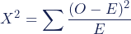
Binomial Test:
The binomial test is used when an experiment has two possible outcomes (i.e. success/failure) and you have an idea about what the probability of success is. A binomial test is run to see if observed test results differ from what was expected.

Assumptions for the Binomial Test
- Items are dichotomous (i.e. there are two of them) and nominal.
- The sample size is significantly less than the population size.
- The sample is a fair representation of the population.
- Sample items are independent(one item has no bearing on the probability of another).

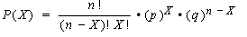
Calculation:
For chi-sq test:
- Enter the data under a single variable assigning labels to the different species.
- Transform > aumatic recode > move species to variable box and give new numeric name to the colum
- Analyse non para >legacy dialog > chi-sqproportion= equal ok.
For binomial test:
- Enter the data under a single variable assigning labels to the different species.
- Analyse non-parametriclegacy dialog binomial testproportion= 0.5 ok.
Practical-10 Run test

Problem:
- From Table 10.1, using a suitable non-parametric test, check whether the age of the persons given is random or not

Table 10.1. Observed age of 50 respondents in a survey

SN | Age | SN | Age | SN | Age
1 | 45 | 18 | 56 | 35 | 58
2 | 44 | 19 | 78 | 36 | 67
3 | 58 | 20 | 12 | 37 | 78
  - Using number of runs of above and below the median, test for randomness for the data provided in Table 10.2.
Table 10.2. Measurements on one variable for randomness
Serial No | Observation | Serial No | Observation
1 | 15 | 16 | 28
2 | 77 | 17 | 26
3 | 1 | 18 | 46
Theory:
Run test
The distribution of variable under consideration is continuous and measurement the variable should be at least on ordinal scale.
For large sampling distribution,
Ho: The Variable under consideration is randomly distributed
H1: The variable under consideration is not randomly distributed
The sampling distribution under Ho is approximately normaly distributed with
Mean = $μ_{r}= \frac{2n1n2}{n1+n2}+1$
And variance $\frac{2n1n2(2n2n2-n1-n2)}{{\left(n1+n2\right)}^{2}(n1+n2-1)}$
Then $Z\sim \frac{\left|r-μ_{r}\right|-0.5}{σ_{r}}$ and Z test is applied.
Calculation
      - RUN TEST data enter in two colums name sn. and age, Analyze > nonpara > legacy > runs >move age to test variable list > tick the median checkbox > ok

Practical-11 (Sign test)

Problem:
An experiment was carried out to compare 2 schemes of finding grass eating animals. Scheme A is new construct method and Scheme B is prevalent conventional method. 13 pairs of identical twin cows have been used in the experiment. One cow from each pair is chosen randomly to be fed according to scheme A and other according to be Scheme B. Their corresponding gains in weights before and after diet are as follows:

Serial No. | Scheme A | Scheme B
1 | 20.10 | 19.50
2 | 19.50 | 18.70
3 | 19.00 | 19.00
Assuming that the distribution of weight gain is unknown, test whether the two schemes are different or not.

Theory:
We will used paired sample sign test. It is the non-parametric equivalent of Paired sample t-test. We compare the mean of differences instead of difference of means in the sign test as compared to parametric t-test.
Sign test
H0: There exists no significant difference between the marks given by 2 professors.
H1: There exist significant difference between the marks given by 2 professors.
For paired observation (Xi, Yi), we define Di = Xi – Yi for all i,
As the median of differences (Xi-Yi) is not necessarily of median i.e. µ_{x} - µ_{y}, so Paired sign test is a test for the median of difference but not for the differences of the medians
And apply the testing procedure of single sample sign test.
Here Di approaches to normal distribution with mean = N/2 and variance = N/4
The test statistic for large sample size (>= 35) in this case becomes:
Z = $\frac{x- μ}{σ_{x}}$ ~ N(0,1)
Decision Rule
Reject the Ho is Z> Zα/2 and accept otherwise.
Calculation:
- Create 2 variables for cow weights of scheme A and of scheme B and enter the data
- Analze non-parametric legacy 2 related sample test selected the 2 variables of cow weight check the sign test box ok.

Practical 12 Kolmogorov Smirnov, Mann Whitney U test.

Problem :
- From Table 10.1, use one sample Kolmogorov Smirnov test to test whether the sample comes from a normal distribution or not.
- Using a suitable non-parametric test, test whether whether there is no difference between the heights of male and female students

Table 12.1
Height_Male | Height_Female
193 | 178
188 | 173
185 | 168
183 | 165
180 | 163
175
170

Theory:
- The Kolmogorov-Smirnov (KS) test is a non-parametric test used to assess whether a sample comes from a specific distribution. It is often used to test the hypothesis that a sample is drawn from a normal distribution or another known distribution.

Ho: The samples come from a normal population. H1 :The samples don not come from .
Steps:
  - Calculate the cumulative distribution function (CDF) of the theoretical distribution.
  - For each observed value in the sample, calculate the difference between the empirical distribution function (EDF) and the CDF.

Test statistic = maximum absolute difference between the EDF and CDF.

Test Criteria: Compare the test statistic to critical values from the Kolmogorov-Smirnov distribution or use it to calculate a p-value.
If the p-value is less than the chosen significance level (commonly 0.05), you reject the null hypothesis.

- To test the hypothesis of no difference between height of male and female students we use Mann Whitney U test.

Ho: There is no significant difference between height of male and female students. H1 : There is a significant difference between height of male and female students.
Steps: Rank all the values from the combined dataset from smallest to largest. Ties receive the average of the ranks they would have received if they were distinct values.
Test Citeria: Compare the U statistic to critical values from the Mann-Whitney U distribution or use it to calculate a p- value. If the p-value is less than the chosen significance level (commonly 0.05), we reject the null hypothesis and conclude that there is a significant difference between the two groups.

Calculations:
- Analyze -> Nonparametric Test ->Legacy Dialogs -> 1 sample K-S Test ; select male and female heights as test variable list and Normal as test distribution.
- Rank all the values from the combined dataset from smallest to largest.
- Analyze -> Nonparametric Test ->Legacy Dialogs -> 2-independent sample Test; select grouping variable and test type as Mann Whitney Test.

Practical-13 Kruskal wallis test

Problem:
Three groups of subjects imitated certain behaviour under three conditions: Reward, Punishment and Ignored. Their imitation scores are given below. Examine whether the three groups differ significantly in terms of their imitation behaviour or not?

Table 13.1. Imitation scores on three different behaviour of persons
Reward imitation behaviour | Punishment imitation behaviour | Ignored imitation behaviour
8 | 0 | 2
12 | 1 | 3
13 | 2 | 4
16 | 3 | 6
19 | 4 | 7
21 | 5 | 10
22 | 6 | 12
23 | 7 | 14
 | 8 | 16

Theory:
Non para test < (Kruskal wallis test)
Calculation:
- Enter the data , scores in one column and imitation behavior to the corresponding scores in the adjacent column.
- Analyse < Non Paras < legacy < k ind sample < tick Kruskal walis < move score var to test variable list box and move behavior var to grouping var then define range (1,3) < continue
Practical-14 (Friedmantest)

Problem:
Five group of subjects were examined for four learning methods. Their scores are given in Table 14.1:

Table 14.1. Scores of four learning methods of five group of subjects
Learning method
Groups | S₁ | S₂ | S₃ | S₄
1 | 10 | 12 | 18 | 21
2 | 12 | 11 | 9 | 8
3 | 18 | 17 | 11 | 24
4 | 16 | 15 | 14 | 7
5 | 15 | 13 | 21 | 3

Does the data indicate a difference in the true mean scores for the four learning methods? Test for a difference in the true mean scores using Friedman’s Test. Use α = 0.01.
Theory:
The Friedman test is the non-parametric alternative to the one-way ANOVA with repeated measures. It is used to test for differences between groups when the dependent variable being measured is ordinal. It can also be used for continuous data that has violated the assumptions necessary to run the one-way ANOVA with repeated measures (e.g., data that has marked deviations from normality).

Assumptions

Assumption #1: One group that is measured on three or more different occasions.
- Assumption #2: Group is a random sample from the population.
- Assumption #3: Your dependent variable should be measured at the ordinal or continuous level.
The null hypothesis (H₀): µ₁ = µ₂ = µ₃ (the mean reaction times across the populations are all equal)
The alternative hypothesis: (Ha): at least one population mean is different from the rest.
- Given data 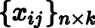, that is, a matrix with rows (the blocks), columns (the treatments) and a single observation at the intersection of each block and treatment, calculate
the ranks within each block. If there are tied values, assign to each tied value the average of
the ranks that would have been assigned without ties. Replace the data with a new matrix 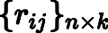 where the entry is the rank of within block .
- Find the values 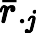 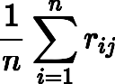
- The test statistic is given by 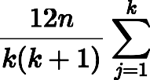 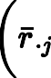 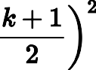. Note that the value of does need to be adjusted for tied values in the data.[4]
- Finally, when or is large (i.e. or ), the probability distribution of can be approximated by that of a chi-squared distribution. In this case the p-value is given by
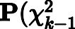
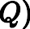 . If or is small, the approximation to chi-square becomes poor and the p- value should be obtained from tables of specially prepared for the Friedman test. If the p- value is significant, appropriate post-hoc multiple comparisons tests would be performed
Calculation:
Click Analyze > Nonparametric Tests > Legacy Dialogs > K Related Samples put s1, s2, s3, s4 in test variable< Friedman Test OK

PRACTICAL- 15 (PCA)
AIM – To perform factor analysis.
PROBLEM – Let us consider a dataset prepared by observing 11 variables related to sandalwood oil parameters and denoted by C₁,...,C₁₁ (Table 15.1). Each variable was measured on the sample taken from 25 different places of South India. The idea is to group these variables and form factors (better known as latent factors).
Table 15.1. Values of sandalwood oil parameters observed from 25 different locations of South India
location | C1 | C2 | C3 | C4 | C5 | C6 | C7 | C8 | C9 | C10 | C11
1. | 3331 | 3060 | 2963 | 2872 | 1691 | 1656 | 1453 | 1374 | 1003 | 878 | 851
2. | 3334 | 3065 | 2971 | 2879 | 1687 | 1657 | 1461 | 1382 | 1004 | 878 | 853
3. | 3331 | 3059 | 2970 | 2876 | 1685 | 1655 | 1460 | 1380 | 1001 | 877 | 852
24. | 3337 | 3051 | 2966 | 2873 | 1692 | 1658 | 1453 | 1375 | 1002 | 879 | 850
25. | 3335 | 3050 | 2966 | 2873 | 1693 | 1660 | 1457 | 1375 | 1003 | 880 | 851
Perform the factor analysis by using its usual four steps (i) Computing correlation matrix for all the factors (ii) Factor extraction, i.e. the number of factors necessary to represent the data and the method of calculating them including of scree plot (iii) Rotation for transforming the factors (using Varimax normalized rotation) to make them more interpretable (iv) Computing the scores of each factor.
THEORY –
Factor analysis is a statistical technique used to identify underlying factors that explain the correlations between a set of observed variables. It aims to reduce the dimensionality of the data by grouping highly correlated variables into a smaller number of latent factors.
Correlation Matrix: The correlation matrix R measures the linear relationship between all pairs of variables. It helps identify potential underlying factors that explain the covariation among the variables.
$$r_{xy}=\frac{\sum_{i=1}^{n}{\left(x_{i}-\overline{x}\right)\left(y_{i}-\overline{y}\right)}}{\sqrt{\sum_{i=1}^{n}{{\left(x_{i}-\overline{x}\right)}^{2}\sum_{i=1}^{n}{{\left(y_{i}-\overline{y}\right)}^{2}}}}}$$
Factor Extraction: PCA aims to identify a smaller set of uncorrelated variables, called principal components, which explain most of the variance in the original data. These components are linear combinations of the original variables and are ordered by decreasing importance based on their explained variance.
$PC_{i}=\sum_{j=1}^{p}{a_{ij}}X_{j}$., where
PC_{i} is the i-th principal component and a_{ii} is the loading of variable i on the i-th principal component.
We calculate the correlation matrix or covariance matrix of the standardized data. Then we find the eigenvalues and eigenvectors of the correlation (or covariance) matrix. Select the eigenvectors corresponding to the eigenvalues greater than 1 (Kaiser criterion). Calculate the loadings by projecting the standardized variables onto the selected eigenvectors. Compute the component scores for each case using the formula above.
Scree Plot: In PCA, the scree plot visualizes the eigenvalues of the correlation matrix. The eigenvalues represent the variance explained by each principal component. The scree plot helps determine the number of components to retain by looking for the "elbow" point where the slope changes significantly. Higher eigenvalues correspond to more important principal components that explain more variance. Components with eigenvalues smaller than 1 explain less variance than a single variable and can be discarded.
Varimax Normalized Rotation for Factor Analysis: Varimax normalized rotation is a method used to improve the interpretability of factors extracted through factor analysis. It aims to achieve two key goals:1. Increase the independence of factors 2. Concentrate the variance of each variable on a few factors. The objective function for Varimax rotation is:$Q=\sum_{j}{{\left(\sum_{i}{a_{ij}^{2}}\right)}^{2}}$,where:a_{ij} is the loading of variable j on factor i.
Normalization: To ensure fair comparison of loadings across components with different eigenvalues, Varimax normalized loadings are calculated as:$a_{ij}^{norm}=\frac{a_{ij}}{\sqrt{\sum_{k}{a_{jk}^{2}}}}$ , a_{jk} is the loading of variable j on factor k.
Factor Score: Factor score for case i on component f:$Z_{i}=\sum_{j=1}^{f}{a_{ij}^{norm}}F_{j}$where: Z_{i} is the factor score of case i on factor f. and F_{j} is the score of case i on rotated and normalized component f.
CALCULATIONS –
- Analyze-> Dimension Reduction -> Factor ->Select the variables you want to analyze -> Click on Descriptives and select KMO and Bartlett's Test of Sphericity to assess data suitability for factor analysis.

- In the Extraction tab: Choose Principal component analysis as the extraction method -> tick correlation matrix, tick unrotated factor solution, tick scree plot < based on eigen values greater than 1

- In the Rotation tab: Choose Varimax as the rotation method ->Select Normalized to apply Kaiser normalization->Continue

PRACTICAL-16 cluster analysis

AIM – To perform Cluster analysis.
PROBLEM – Consider the following eight locations (A, B, C, D, E, F, G and H) that have various levels of pollutants in air, water and soil (Table 16.1). One is interested in grouping places having similar levels of pollution load.
Table 16.1: Observed value of pollutants
Location | CO | SO₂ | NO₂ | PM 10 | PM 2.5
A | 72 | 0.05 | 125 | 22 | 52
B | 75 | 0.01 | 123 | 19 | 63
C | 100 | 0.69 | 98 | 26 | 124
Perform the cluster analysis by selecting a distance measure, selecting a clustering procedure, deciding the number of clusters, interpreting the profile clusters and finally, assessing the validity of clustering.

THEORY-
Cluster analysis is a statistical technique used to group similar entities based on their observed characteristics. The goal is to identify natural groupings within a dataset, enabling insights into underlying patterns or structures. Let X be the matrix of observed values with rows representing locations and columns representing pollutants. The distance between two locations i and j can be calculated using a distance measure, such as Euclidean distance:
$$d\left(x_{i},x_{j}\right) is the Euclidean distance\frac{b}{w}data points x_{i},andx_{j}.$$
$$x_{ik}is the value of the kth variable for data point x_{\begin{aligned}i. \\ \end{aligned}}$$
$p is the number of variables$.
$d\left(x_{i},x_{j}\right)=\sqrt{\sum_{k=1}^{p}{{\left(x_{ik}-x_{jk}\right)}^{2}}}$, where:
The linkage criterion for clustering can be based on the minimum distance (single linkage), maximum distance (complete linkage), or average distance between observations.
The aim is to perform cluster analysis on pollutant levels at different locations, selecting an appropriate distance measure and clustering procedure. The number of clusters will be determined based on the dataset characteristics, and the interpretation of resulting clusters will provide insights into similarities or differences in pollution profiles.

Ward's hierarchical clustering method: This method minimizes the within-cluster variance at each step of merging clusters. It uses the following formula to calculate the distance between clusters:
$$D\left(C_{i},C_{j}\right)=\frac{\left(n_{i}+n_{j}\right)}{n_{i}+n_{j}+n_{k}}d\left(x_{i},x_{k}\right)+\frac{\left(n_{i}+n_{k}\right)}{n_{i}+n_{j}+n_{k}}d\left(x_{j},x_{k}\right)$$
where:
- D(C_{i}, C_{j}) is the distance between clusters C_{i} and C_{j}.
- n_{i} is the number of data points in cluster C_{i}.
- d(x_{i}, x_{k}) is the distance between data points x_{i} and x_{k}.

CALCULATIONS-
Analyze -> Classify -> Cluster -> Hierarchical Cluster -> Put all the pollutants under Variables(s) and Label Cases - “Location” -> Statistics (as it is) -> Plots - Dendogram -> Method - Cluster Method - B/W groups Linkage -> Interval - Euclidean Distance -> OK.

PRACTICAL-17 dissimilarity (Euclidean distance)
Aim: The aim here is to identify clusters of treatments based on the dissimilarity (Euclidean distance) between them.
Problem: Table 17.1 shows the adjusted means of 8 characters observed in an experiment to evaluate 110 genotypes of Lentil conducted using an alpha-design in 3 replications with block size 10
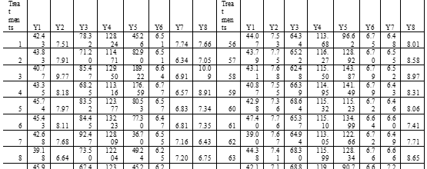
- Using the data, compute Euclidean distances between pairs of treatments. Treating the computed distance as measure of (dis) similarity, perform hierarchical cluster analysis with unweighted pair-group method using arithmetic averages (UPGMA) method.
- Construct the dendrogram.
Theory:
Cluster analysis is a statistical technique used to group similar entities based on their observed characteristics. The goal is to identify natural groupings within a dataset, enabling insights into underlying patterns or structures. Let X be the matrix of observed values with rows representing locations and columns representing pollutants. The distance between two locations i and j can be calculated using a distance measure, such as Euclidean distance:
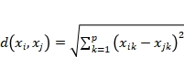, where:
The linkage criterion for clustering can be based on the minimum distance (single linkage), maximum distance (complete linkage), or average distance between observations.
The aim is to perform cluster analysis on pollutant levels at different locations, selecting an appropriate distance measure and clustering procedure. The number of clusters will be determined based on the dataset characteristics, and the interpretation of resulting clusters will provide insights into similarities or differences in pollution profiles.
Ward's hierarchical clustering method: This method minimizes the within-cluster variance at each step of merging clusters. It uses the following formula to calculate the distance between clusters:
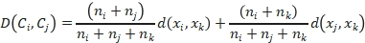
where:
- D(C_{i}, C_{j}) is the distance between clusters C_{i} and C_{j}.
- n_{i} is the number of data points in cluster C_{i}.
- d(x_{i}, x_{k}) is the distance between data points x_{i} and x_{k}.

Steps and Output:
- Go to the "Analyze" menu.
- Select "Classify" and then choose "Hierarchical Cluster Analysis".
- In the dialogue box that appears:
  - Choose the variables (Y1,Y2,Y3,Y4,Y%,Y6,Y7,Y8) as your clustering variables. And in label cases drag “TRT”.
  - Select a distance measure (e.g., Euclidean distance).
  - Select Statistics (as it is) -> Plots - Dendogram -> Method - Cluster Method - B/W groups Linkage.
  - Run the analysis

Result:
- The height of the branches where clusters merge represents the dissimilarity between clusters.
- At Stage 1, Cluster 36 and Cluster 51 were merged with a coefficient of 1.612.
- Stage 2 saw the merging of Cluster 53 and Cluster 59 with a coefficient of 3.421.
- As the stages progress, different clusters merge at varying coefficients, signifying their level of similarity or dissimilarity.
- The dendrogram visually represent the clustering structure and dissimilarity between treatments

PRACTICAL-18 Karl Pearson’s Test of Goodness of Fit

Aim: To perform Karl Pearson’s Test of Goodness of Fit
Problem:
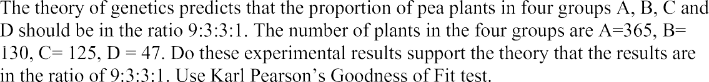
Theory:
H0: The proportion of pea plants in four groups A, B, C and D should be in ratio 9:3:3:1
H1:: The proportion of pea plants in the four groups should not be in the mentioned ratio.
Steps And Output:
1-Go to Analyse -> Non-Parametric Tests -> Chi- Square
2-Enter the observations as Test variable (Data typed as: A 365 times, B – 130 times, C – 125 times, D – 47 times) -> Under Expected Values enter 9, 3, 3, and 1 as values
3-Then click OK
Chi-Square Test Frequencies
Result:
From table 18.2 we have value of test statistic of Karl Pearson Goodness of Fit test equal to 1.149 and the p-value =0.765 which is greater than 0.05, hence we may accept the null hypothesis at 5% level of significance and infer that the experimental results supports the theory that the results are in the ratio 9:3:3:1

PRACTICAL-19 (regression model)

Aim: To fit simple linear regression model

Problem:
The following data gives the House price in Lakhs(Y) and area in square yards (X) of a reality firm. Fit the simple linear regression model to following data and carry out the analysis.

Y | X | Y | X | Y | X | Y | X
186 | 175 | 182 | 167 | 162 | 156 | 179 | 160
180 | 168 | 162 | 160 | 192 | 180 | 170 | 149
160 | 154 | 169 | 165 | 185 | 167 | 170 | 160
186 | 166 | 176 | 167 | 163 | 157 | 165 | 148
Theory:
Simple linear regression is a statistical method used to model the relationship between a dependent variable (Y) and a single independent variable (X). The model assumes that there is a linear relationship between the variables, and it is represented by the equation:
$$Y=β_{0}+β_{1}⋅X+ε$$

where:
- Y is the dependent variable (house prices),
- X is the independent variable (area in square yards),
- $β_{0}$ is the intercept (constant),
- $β_{1}$ is the slope coefficient (represents the change in Y for a one-unit change in X)
- ε is the error term.

The aim is to estimate the coefficients $β_{0}$ and $β_{1}$ and assess the significance of the relationship between house prices and area.
Steps And Output:
- Examine the descriptive statistics and correlation among X and Y
- Click on Analyse -> Regression -> Linear. Move Y to the ‘Dependent’ and X to the ‘Independent’ box
- In ‘Statistics’ -> select Descriptives -> click ‘Continue’
- In ‘Plots’ -> select *ZRESID -> select ‘Normal probability plot’ -> click ‘Continue’
- Click ‘OK’

Result:

- Mean house price is 174.32 lakhs with standard deviation of 9.960 & mean area is 163.92 square yards with standard deviation of 9.152.
- Pearson correlation coefficient between house price and area is strong, with a value of 0.765 (p < 0.001).
- Model summary indicates a significant relationship (R² = 0.585) between house prices and the area, explaining 58.5% of the variability in house prices.
- ANOVA shows regression model is statistically significant (F(1, 94) = 132.300, p < 0.001 ), indicating that the model adds significant explanatory power compared to a model with no predictors.
- The coefficients table provides the following information:
  - Intercept (= 37.922, p = 0.002 )
  - Slope (= 0.832, p < 0.001 ) signifies that, on average, for each additional square yard, the house price increases by 0.832 lakhs.
- Residuals statistics show that predicted house prices range from 155.25 to 188.54 lakhs. The residuals have a mean close to zero, indicating that the model is unbiased. Standardized residuals and predicted values are also provided.
- Normal P-P Plot suggests standardized residuals follow normal distribution

